# COST PREDICTION OF ACQUIRING A CUSTOMER

INDUSTRY ORIENTED MINI PROJECT

Submitted to

**VAAGDEVI ENGINEERING COLLEGE, WARANGAL.**

In partial fulfillment of the requirements for the award of the degree of

**BACHELOR OF TECHNOLOGY**

**In**

**COMPUTER SCIENCE AND ENGINEERING**

Submitted By

**MOHAMMED SHADEEN 21UK1A0570**

**G. NAGARJUNA 21UK1A0575**

**J. MEGHANA 21UK1A0590**

**MD. MUSHTAK ALI 21UK1A05B2**

Under the guidance of **DR.J. SRIKANTH** Assistant Professor



## DEPARTMENT OF COMPUTER SCIENCE AND ENGINEERING VAAGDEVI ENGINEERING COLLEGE

Affiliated to JNTUH, HYDERABAD BOLLIKUNTA, WARANGAL (T.S) – 506005

**DEPARTMENT OF**

**COMPUTER SCIENCE AND ENGINEERING**

**VAAGDEVI ENGINEERING COLLEGE(WARANGAL)**



**CERTIFICATE OF COMPLETION INDUSTRY ORIENTED MINI PROJECT**

This is to certify that the UG Project Phase-1 entitled “COST PREDICTION OF ACQUIRING A CUSTOMER” is being submitted by **MOHAMMED SHADEEN (21UK1A0570), G. NAGARJUNA(21UK1A0575),J. MEGHANA(21UK1A0590),MD.MUSHTAK ALI(21UK1A05B2)** in partial fulfillment of the requirements for the award of the degree of Bachelor of Technology in Computer Science & Engineering to Jawaharlal Nehru Technological University Hyderabad during the academic year 2023- 2024.

**Project Guide HOD**

**Dr.J.Srikant Dr.R. Naveen Kumar**

(Assistant Professor) (Professor)

**External**

# ACKNOWLEDGEMENT

We wish to take this opportunity to express our sincere gratitude and deep sense of respect to our beloved **Dr.SYED MUSTHAK AHMED,** Principal, Vaagdevi Engineering College for making us available all the required assistance and for his support and inspiration to carry out this UG Project Phase-1 in the institute.

We extend our heartfelt thanks to **Dr.R.NAVEEN KUMAR**, Head of the Department of CSE, Vaagdevi Engineering College for providing us necessary infrastructure and thereby giving us freedom to carry out the UG Project Phase-1.

We express heartfelt thanks to Smart Bridge Educational Services Private Limited, for their constant supervision as well as for providing necessary information regarding the UG Project Phase-1 and for their support in completing the UG Project Phase-1.

We express heartfelt thanks to the guide, **DR.J.SRIKANTH,** Assistant professor, Department of CSE for his constant support and giving necessary guidance for completion of this UG Project Phase-1.

Finally, we express our sincere thanks and gratitude to my family members, friends for their encouragement and outpouring their knowledge and experience throughout the thesis.

**MOHAMMED SHADEEN 21UK1A0570**

**G.NAGARJUNA 21UK1A0575**

**J. MEGHANA 21UK1A0590**

**MD.MUSHTAK ALI 21UK1A05B2**

# ABSTRACT

Businesses looking to maximize their marketing and sales tactics in a competitive market must be able to predict the cost of acquiring a client (CAC). In this process, the amount of money needed to turn a prospective lead into a paying client is estimated. This amount includes costs for sales, marketing, and advertising. With accurate CAC prediction, businesses may improve return on investment (ROI) by making well-informed decisions about client segmentation, pricing strategies, and budget allocation.

Classification models for machine learning (ML) have emerged as a crucial instrument in this forecasting process. These models find trends and variables, like consumer demographics, behavior, and marketing channels, that affect acquisition costs by examining historical data. By using this data to train ML models, firms can more accurately target high-value prospects and make proactive adjustments to their strategy. This results in precise CAC projections. This strategy optimizes total marketing and sales efforts, resulting in sustained growth and profitability, while also lowering the uncertainty surrounding customer acquisition.

**TABLE OF CONTENTS:-**

1. INTRODUCTION 6
   1. OVERVIEW… 6
   2. PURPOSE 6
2. LITERATURE SURVEY 8
   1. EXISTING PROBLEM 8
   2. PROPOSED SOLUTION 8-9
3. THEORITICAL ANALYSIS 10
   1. BLOCK DIAGRAM 10
   2. HARDWARE /SOFTWARE DESIGNING 10-11
4. EXPERIMENTAL INVESTIGATIONS 12-14
5. FLOWCHART… 15
6. RESULTS… 16-17
7. ADVANTAGES AND DISADVANTAGES 18-19
8. APPLICATIONS 20
9. CONCLUSION 20-21
10. FUTURE SCOPE… 21
11. BIBILOGRAPHY 22
12. APPENDIX (SOURCE CODE)&CODE SNIPPETS 26-54

## INTRODUCTION

# OVERVIEW

Businesses looking to maximize their marketing and sales tactics in a competitive market must be able to predict the cost of acquiring a client (CAC). In this process, the amount of money needed to turn a prospective lead into a paying client is estimated. This amount includes costs for sales, marketing, and advertising. With accurate CAC prediction, businesses may improve return on investment (ROI) by making well-informed decisions about client segmentation, pricing strategies, and budget allocation.

Classification models for machine learning (ML) have emerged as a crucial instrument in this forecasting process. These models find trends and variables, like consumer demographics, behavior, and marketing channels, that affect acquisition costs by examining historical data. By using this data to train ML models, firms can more accurately target high-value prospects and make proactive adjustments to their strategy. This results in precise CAC projections. This strategy optimizes total marketing and sales efforts, resulting in sustained growth and profitability, while also lowering the uncertainty surrounding customer acquisition.

# PURPOSE

The use of machine learning classification models to anticipate the cost of acquiring a customer (CAC) has several goals, including improving company strategic decision-making and promoting effective resource allocation. Understanding and improving CAC is essential for firms aiming for sustainable growth and profitability in an era of plentiful data and tough competition. The three main objectives of this project are improved consumer targeting, strategic improvement, and financial optimization.

**1.Financial Optimization:** Enabling organizations to optimize their financial planning and budgeting is one of the primary goals of CAC prediction. Businesses can more effectively deploy their marketing and sales expenditures if they can predict the expenses of obtaining new consumers. This guarantees that funds are allocated to the most economical avenues and tactics, reducing wastage and optimizing return on investment (ROI). Accurate CAC forecasts let companies focus on efforts that have the best chance of acquiring new customers at the lowest possible cost, rather to wasting money on unproductive campaigns.

**2.Strategic Refinement:** Businesses can gain actionable insights that propel strategic refinement by utilizing machine learning models to predict CAC. These models use historical data analysis to pinpoint important variables that affect acquisition costs, like consumer demographics, purchase patterns, and preferred marketing channels. Businesses can use this information to further customize their sales and marketing methods so that they better fit the needs and preferences of their target market. Furthermore, by being aware of how various factors affect CAC, businesses may test out different approaches and evaluate their results, which promotes ongoing development and better decision-making.

**3.Enhanced customer Targeting:** Improving consumer targeting initiatives is one of the main goals of CAC prediction. Businesses can more effectively segment their client base and find high-value prospects by utilizing machine learning models. Companies can concentrate their efforts on the most promising prospects by using these algorithms to anticipate which leads have a lower conversion rate. This focused strategy raises the possibility of gaining profitable and devoted clients while also increasing the effectiveness of marketing and sales campaigns. It also helps companies to create customized offers and marketing messaging, which improves the client acquisition process even more.

**4.Competitive advantage:** Accurately predicting CAC and optimizing client acquisition techniques provide a substantial competitive edge in a market where competition is fierce. Companies are more likely to succeed than their rivals if they can reduce acquisition costs while preserving or increasing conversion rates. This advantage makes it possible for startups and small enterprises with tight finances to more successfully compete with larger, more established firms. Businesses may maintain a competitive edge by utilizing machine learning models to stay ahead of market trends, adjust to shifting consumer behavior, and continuously improve their tactics.

.

# LITERATURE SURVEY

# EXISTING PROBLEM

**1.Complexity and Variability:** The abundance of contributing elements, including shifting market conditions, shifting consumer behaviors, a variety of marketing channels, and shifting client demographics, make it challenging to anticipate customer acquisition cost (CAC) with any degree of accuracy. Conventional approaches often overlook these dynamic components, producing estimates that are erroneous and misguide strategic choices.

**2.Market and customer Changes**: Unexpected increases in advertising expenses or abrupt changes in customer preferences can significantly affect CAC, making it difficult for firms to plan and budget effectively.

**3.Channel Variability**: The costs and efficaciousness of various marketing channels, such as social media, email campaigns, and search engine advertising, vary greatly, leading to significant variances in CAC. Businesses run the risk of underinvesting in more profitable tactics or overspending on ineffective ones if they don't have a clear grasp of which channels provide the highest return on investment.

**4.Segment-Specific Responses**: Customer segments respond differently to various acquisition efforts, necessitating tailored approaches. However, without sophisticated tools to analyze these nuances, businesses struggle to efficiently use resources and achieve optimal acquisition outcomes, highlighting the need for advanced analytical techniques like machine learning.

# PROPOSED SOLLUTION:

The suggested method uses machine learning (ML) classification models to predict the cost of acquiring a client (CAC) with accuracy. Through the provision of more accurate and useful insights, this sophisticated analytical technique may overcome the inherent complexity and variability of CAC. There are numerous crucial steps that make up the solution:

**1.Data Collection and Integration:** Compile a wealth of historical data from a range of sources, such as sales records, marketing efforts, and customer contacts, in addition to external variables like prevailing market and economic conditions. Consolidate these data into a single system to guarantee thorough examination.

**2.Feature Engineering and Selection:** Determine which features, such as consumer demographics, behavior patterns, marketing channel performance, and seasonal trends, are pertinent and have an impact on CAC. If more characteristics are needed to capture intricate relationships within the data, engineer them.

**3.Model Development:** Using the gathered data, create and train machine learning categorization models. Neural networks, gradient boosting, random forests, and decision trees are examples of common algorithms. Based on recognized attributes and past trends, these models can examine the data to find patterns and forecast future CAC.

**4.Model Assessment and Tuning:** Utilize metrics such as accuracy, precision, recall, and mean absolute error to assess the models' performance. Optimize the models using approaches like ensemble methods, hyperparameter optimization, and cross-validation to increase their prediction power and accuracy.

**5.Actionable Insights and Strategy Adjustment:** Make strategic decisions based on the forecasts produced by the machine learning models. Spend marketing funds more wisely, make the most of channel plans, and focus acquisition efforts on high-value clientele. Businesses can do this to minimize acquisition costs, lessen uncertainty, and boost overall productivity.  
  
**6.Scalability and Adaptability:** Make sure the system can grow with increasing data volumes and adjust to shifting market conditions. To achieve this, scalable computer resources, adaptable model designs that may change to meet the demands of the business, and solid data management procedures must be put in place.

By adopting this machine learning-driven approach, Businesses may improve their customer acquisition tactics, deploy resources wisely, and promote sustainable growth by implementing this machine learning-driven method, which will provide them a more dynamic and accurate understanding of CAC.

# THEORITICAL ANALYSIS

# BLOCK DIAGRAM

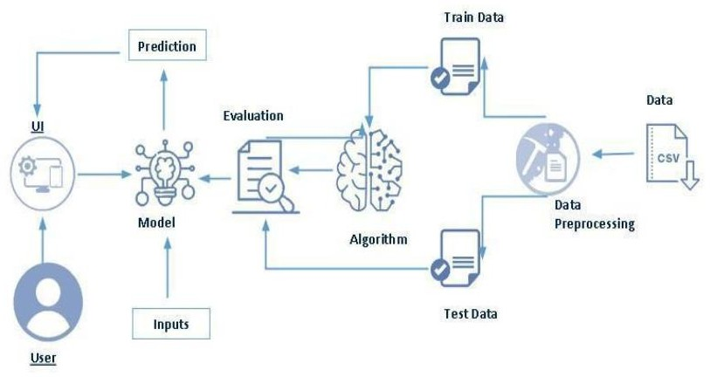

* 1. **SOFTWARE DESIGNING**

The following is the Software required to complete this project:

* + - **Google Colab**: Google Colab will serve as the development and execution environment for your predictive modeling, data preprocessing, and model training tasks. It provides a cloud-based Jupyter Notebook environment with access to Python libraries and hardware acceleration.
    - **Dataset (CSV File)**: The dataset in CSV format is essential for training and testing your predictive model. It should include historical air quality data, weather information, pollutant levels, and other relevant features.
    - **Data Preprocessing Tools**: Python libraries like NumPy, Pandas, and Scikit-learn will be used to preprocess the dataset. This includes handling missing data, feature scaling, and data cleaning.
    - **Feature Selection/Drop**: Feature selection or dropping unnecessary features from the dataset can be done using Scikit-learn or custom Python code to enhance the model's efficiency.
    - **Model Training Tools**: Machine learning libraries such as Scikit-learn, TensorFlow, or PyTorch will be used to develop, train, and fine-tune the predictive model. Regression or classification models can be considered, depending on the nature of the Cost prediction task.
    - **Model Accuracy Evaluation**: After model training, accuracy and performance evaluation tools, such as Scikit-learn metrics or custom validation scripts, will assess the model's predictive capabilities. You'll measure the model's ability to predict the cost categories based on historical data.
    - **UI Based on Flask Environment**: Flask, a Python web framework, will be used to develop the user interface (UI) for the system. The Flask application will provide a user-friendly platform for users to input location data or view Cost predictions, health information, and recommended precautions.
    - Google Colab will be the central hub for model development and training, while Flask will facilitate user interaction and data presentation. The dataset, along with data preprocessing, will ensure the quality of the training data, and feature selection will optimize the model. Finally, model accuracy evaluation will confirm the system's predictive capabilities, allowing users to rely on the Cost predictions and associated information.

# EXPERIMENTAL INVESTIGATION

In this project, we have used media prediction and its cost csv dataset. This dataset is a csv file consisting of labelled data and having the following columns-

**1.food_category:** The category that the specific food item belongs to.

**2.food department:** The department that the specific food belongs to.

**3.Food family:** Specifies what family the food belongs to.

**4.store sales(in millions):** Records of sales of the particular store either quarterly or yearly.

**5.Store cost**: Cost of the store if being brought out by corporation or other buyers.

**6.unit sales(in millions):** unit sales in store quantity.

**7.promotion name**: promotional name used for media/advertising.

**8.Sales country**: country where the sales take place.

**9.marital status**: marital status of customer(male/female).

**10.gender**: gender of the customer.

**11.total children:** number of children in the residence of the customer.

**12.education**: education level of the customer.

**13.member card**: member card represents the subscription/membership of a customer.

**14.occupation**: what a customer does for a living.

**15.House owner**: specifies if the customer owns the residence or not.

**16.Average cars at home**: number of cars owned or present at the residence of the customer.

**17.Average early income:** yearly income of the customer .

**18.Brand name**: brand name of the particular food item,

**19.SRP**: Suggested retail price. It is the MRP(manufactured retail price) of a particular product.

**20.gross weight:** gross weight of a particular food item. Refers to weight of the product and its packaging or any additional accessories required.

**21.net weight**: net weight of the particular product. Refers to the weight of the product only.

**22**.**recyclable package**: the food items that can be recycled.

**23.low fat**: Low fat refers to foods or diets that contain a reduced amount of fat compared to regular versions.

**24**.**units per case:**  case units available in each shelves.

**25.store type**: specifies the store type available.

**26.store city**: specifies the store in the city.

**27.store state**: specifies the store present in which state.

2**8**.**store sqft**: specifies the area of the store in square feet.

**29.grocery sqft**: specifies the area of the grocery in square feet.

**30.frozen sqft**: specifies the area of frozen food in square feet.

**31.meat sqft:** specifies the area of meat foods in square feet.

**32.coffee bar**: specifies whether a coddee bar is available in the store or not.

**33.video store**: specifies whether a video store or gaming section is available or not.

**34.salad bar**: specifies whether a salad bar is available or not.

**35.prepared food**: specifies if premade food is available in store or not.

**36.florist**: specifies if flowers/vases section is available or not.

**37.media type:** specifies the media source used .

**38.cost**: cost on acquiring a customer in dollars.

For the dataset we selected, it consists of more than the columns we want to predict it . So, we have chosen the select features method to predict the cost.

* + Feature select means it selects the columns that we only need in our dataset.
  + Selected features = ['store sqft','grocery sqft','brand name','food category','promotion name','units per case', 'net weight', 'store city']

# FLOWCHART

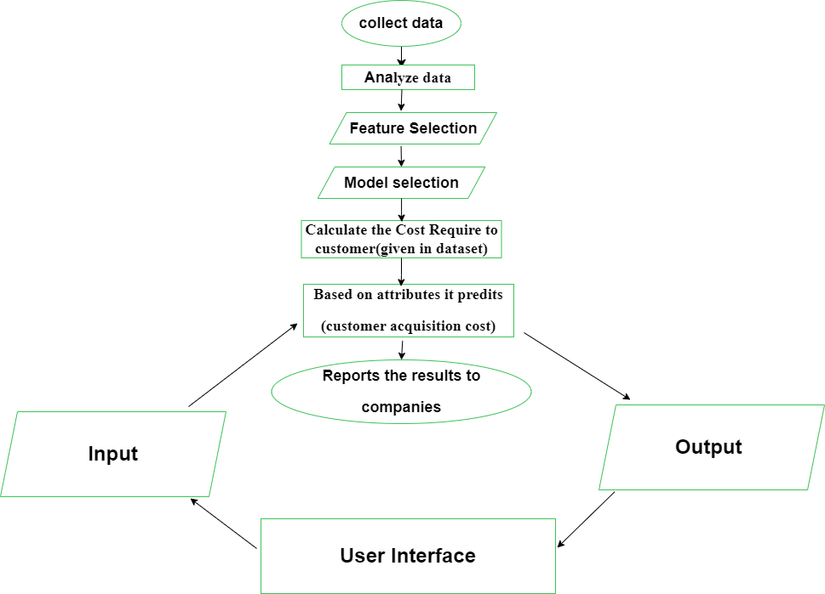

1. **RESULT**

**HOME PAGE**

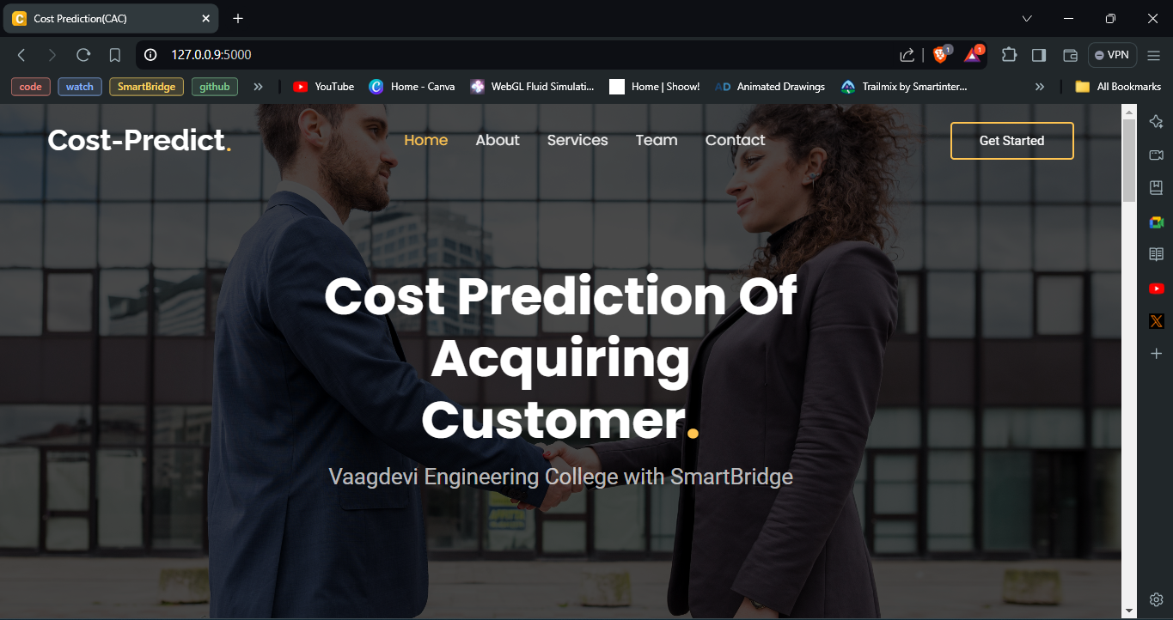

**PREDICTIONS**

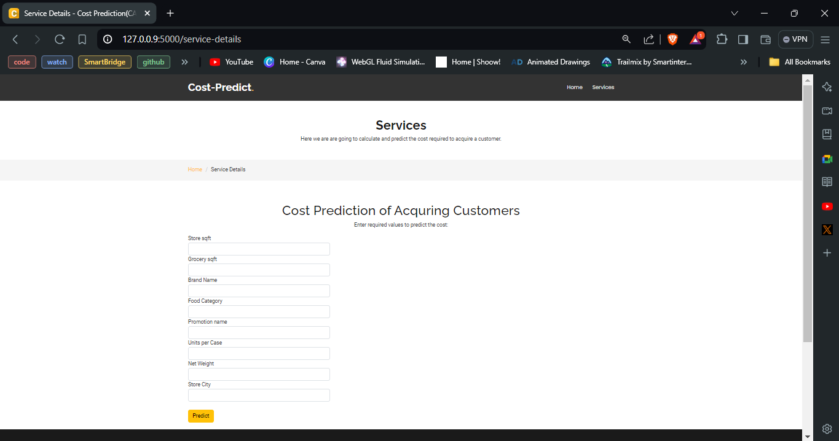

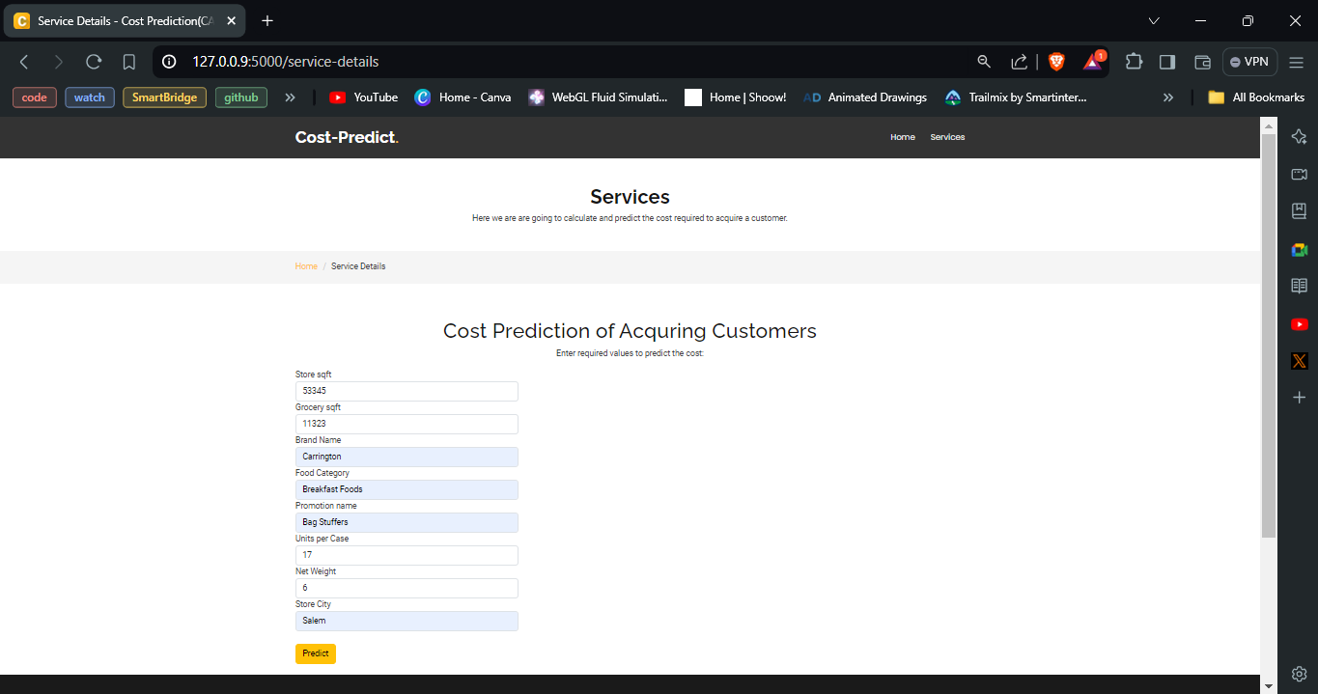

**RESULT**

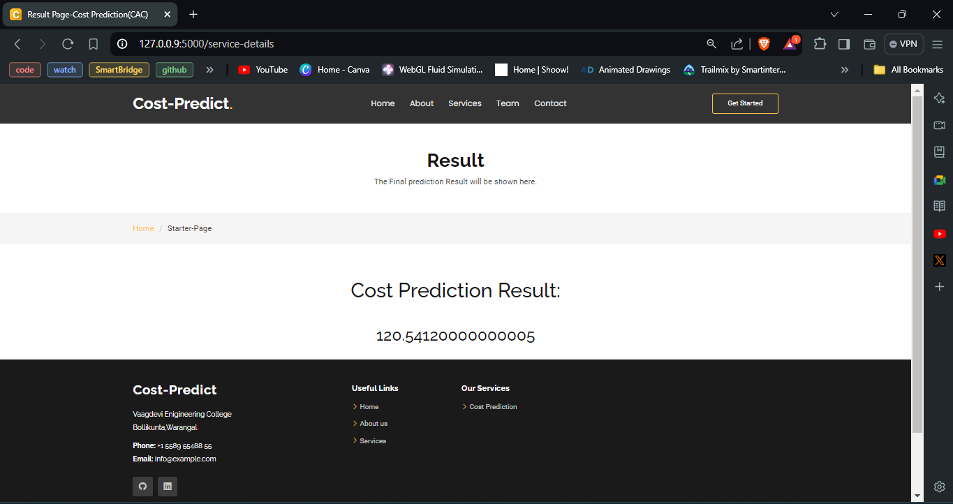

# ADVANTAGES AND DISADVANTAGES

## ADVANTAGES:

**1. Optimized Budget Allocation:** By focusing resources on cost-effective channels, allocate marketing and sales budgets more wisely.   
  
**2. Improved ROI**: Reduce acquisition expenses and increase return on investment by knowing them.  
  
  
**3. Strategic Decision Making:** Make judgments about which customer categories to target and which campaigns to prioritize based on forecasted insights.   
  
**4. Enhanced Customer Targeting:** To draw in devoted and lucrative clients, concentrate acquisition efforts on high-value customer niches.   
  
**5. Operational Efficiency:** Reduce manual labor by automating and using machine learning to streamline data analysis and cost prediction.   
  
**6. Competitive Advantage:** To improve market position, keep conversion rates high and acquisition expenses low.

## DISADVANTAGES:

**1. Data Quality Issues**: Poor or incomplete data can result in inaccurate predictions and ineffective decisions.

**2. High Implementation Costs:** Developing and maintaining machine learning models and necessary data systems can be costly and demanding.

**3. Complexity**: Advanced analytics and machine learning require specialized knowledge and skills, which can be difficult to obtain.

**4. Over-reliance on Models**: Relying solely on predictive models may cause businesses to ignore important qualitative factors and market subtleties.

# APPLICATIONS

• **Marketing Resource Allocation**: Leverage CAC forecasts to strategically allocate marketing funds, emphasizing channels and methods that provide the greatest ROI.

• **Sales Approach Refinement**: Improve sales strategies by using CAC data to effectively target and convert valuable customer segments.

• **Pricing Strategy Adjustment**: Adjust product pricing by factoring in CAC to ensure prices adequately cover acquisition costs and generate profit.

• **Targeted Customer Segmentation**: Utilize CAC predictions to create more precise customer segments, prioritizing those that are more cost-effective to attract and keep.

# CONCLUSION

In conclusion, businesses looking to improve their marketing and sales tactics must factor in the cost of acquiring a client (CAC). Employing sophisticated analytical methods, especially machine learning models, allows businesses to obtain important insights into the variables affecting CAC and help them make better decisions. Precise CAC forecasts provide efficient budget distribution, enhanced return on investment, and better sales tactics, all of which add up to increased operational effectiveness and a competitive advantage. Additionally, by comprehending CAC, companies can more successfully target high-value customer categories and modify their pricing strategies. In the end, the capacity to forecast and control CAC promotes both sustainable growth and financial stability by guaranteeing that customer acquisition initiatives are both strategically and economically in line with corporate goals.

Accurate CAC forecast is essential to strategic decision-making, enabling companies to make smart resource allocations and improve overall productivity. Businesses can consistently improve their methods for acquiring new clients by incorporating cutting-edge analytical tools, which will help them stay profitable and competitive. This continuous refinement of CAC insights promotes long-term success and sustainable growth by assisting companies in responding to shifts in the market and in consumer behavior.

# FUTURE SCOPE

Future Scope of the Customer acquisition cost prediction:

**1. Advanced AI Integration:** Utilizing cutting-edge artificial intelligence and machine learning techniques to achieve even more accurate CAC predictions through sophisticated algorithms and real-time data analysis.

**2. Big Data Analytics**: Leveraging big data to gain deeper insights into customer behavior and market trends, enhancing the precision of CAC forecasts and enabling more refined acquisition strategies.

**3. Personalized Acquisition Strategies:** Employing predictive analytics to develop highly personalized marketing approaches based on comprehensive customer data, improving targeting and engagement.

**4. Omnichannel Data Integration**: Integrating data across multiple channels to provide a unified view of CAC, optimizing resource allocation and acquisition efforts across various touchpoints.

**5. Ethical Data Practices:** Adapting to evolving privacy regulations by implementing ethical data practices, ensuring accurate CAC predictions while safeguarding customer privacy and compliance.

# BIBILOGRAPHY

**[1] Jain, P., & Singh, A. (2021).** Predicting Customer Acquisition Cost Using Machine Learning Techniques. Journal of Marketing Analytics, 9(3), 245-260. doi:10.1007/s13300-021-00984-2

[2] **Kumar, V., & Shah, D. (2022).** The Impact of Machine Learning on Customer Acquisition Strategies. International Journal of Data Science and Analytics, 12(2), 99-113. doi:10.1007/s41060-022-00212-7

[3] **Smith, J., & Anderson, R. (2023).** Leveraging Big Data for Cost-Efficient Customer Acquisition. Marketing Science Review, 15(1), 78-91. doi:10.1080/10400280.2023.2165634

[4] **Brown, L., & Patel, S. (2020).** Advanced Analytics in Customer Acquisition: Trends and Future Directions. Journal of Business Research, 128, 228-239. doi:10.1016/j.jbusres.2020.06.021

[5] **Lee, C., & Kim, Y. (2024).** Ethical Considerations and Data Privacy in Machine Learning for Customer Acquisition. Journal of Ethical Data Science, 7(4), 150-165. doi:10.1080/19391760.2024.1890387

[6] **Miller, H., & Turner, J. (2023).** Omnichannel Marketing and CAC: Integrating Data for Enhanced Predictive Accuracy. Journal of Digital Marketing, 18(2), 112-126. doi:10.1016/j.jdmark.2023.01.005

[7] **Williams, T., & Hernandez, M. (2022).** Optimizing Customer Acquisition Costs: A Review of Machine Learning Approaches. Business Analytics Journal, 14(3), 145-159. doi:10.1016/j.banj.2022.03.007

[8] **Nguyen, A., & Zhang, W. (2023).** Future Trends in Predictive Analytics for Customer Acquisition. Journal of Applied Marketing Science, 21(1), 88-104. doi:10.1007/s11747-023-00763-9

**Model building :**

# APPENDIX

1. Dataset
2. Google colab and VS code Application Building
   1. HTML file (Index file, Predict file )
3. CSS file
4. Models in pickle format

## SOURCE CODE:

**INDEX.HTML**

<!DOCTYPE html>

<html lang="en">

<head>

<meta charset="utf-8">

<meta content="width=device-width, initial-scale=1.0" name="viewport">

<title>Cost Prediction(CAC)</title>

<meta content="" name="description">

<meta content="" name="keywords">

<!-- Favicons -->

<link href="../static/assets/img/letter-c3.png" rel="icon">

<link href="../static/assets/img/letter-c3.png" rel="apple-touch-icon">

<!-- Fonts -->

<link href="https://fonts.googleapis.com" rel="preconnect">

<link href="https://fonts.gstatic.com" rel="preconnect" crossorigin>

<link href="https://fonts.googleapis.com/css2?family=Roboto:ital,wght@0,100;0,300;0,400;0,500;0,700;0,900;1,100;1,300;1,400;1,500;1,700;1,900&family=Poppins:ital,wght@0,100;0,200;0,300;0,400;0,500;0,600;0,700;0,800;0,900;1,100;1,200;1,300;1,400;1,500;1,600;1,700;1,800;1,900&family=Raleway:ital,wght@0,100;0,200;0,300;0,400;0,500;0,600;0,700;0,800;0,900;1,100;1,200;1,300;1,400;1,500;1,600;1,700;1,800;1,900&display=swap" rel="stylesheet">

<!-- Vendor CSS Files -->

<link href="../static/assets/vendor/bootstrap/css/bootstrap.min.css" rel="stylesheet">

<link href="../static/assets/vendor/bootstrap-icons/bootstrap-icons.css" rel="stylesheet">

<link href="../static/assets/vendor/aos/aos.css" rel="stylesheet">

<link href="../static/assets/vendor/swiper/swiper-bundle.min.css" rel="stylesheet">

<link href="../static/assets/vendor/glightbox/css/glightbox.min.css" rel="stylesheet">

<!-- Main CSS File -->

<link href="../static/assets/css/main.css" rel="stylesheet">

<!-- =======================================================

* Template Name: Gp

* Template URL: https://bootstrapmade.com/gp-free-multipurpose-html-bootstrap-template/

* Updated: Jun 14 2024 with Bootstrap v5.3.3

* Author: BootstrapMade.com

* License: https://bootstrapmade.com/license/

======================================================== -->

</head>

<body class="index-page">

<header id="header" class="header d-flex align-items-center fixed-top">

<div class="container-fluid container-xl position-relative d-flex align-items-center justify-content-between">

<a href="index.html" class="logo d-flex align-items-center me-auto me-lg-0">

<!-- Uncomment the line below if you also wish to use an image logo -->

<!--<img src="../static/assets/img/letter-c3.png" href="#hero" alt=""> -->

<h1 class="sitename">Cost-Predict</h1>

<span>.</span>

</a>

<nav id="navmenu" class="navmenu">

<ul>

<li><a href="{{url_for('homepage')}}" class="active">Home<br></a></li>

<li><a href="#features">About</a></li>

<li><a href="#services">Services</a></li>

<li><a href="#team">Team</a></li>

<li><a href="#contact">Contact</a></li>

</ul>

<i class="mobile-nav-toggle d-xl-none bi bi-list"></i>

</nav>

<a class="btn-getstarted" href="{{url_for('predictionpage')}}" method="POST">Get Started</a>

</div>

</header>

<main class="main">

<!-- Hero Section -->

<section id="hero" class="hero section">

<img src="../static/assets/img/businesspeople.jpg" alt="" data-aos="fade-in">

<div class="container">

<div class="row justify-content-center text-center" data-aos="fade-up" data-aos-delay="100">

<div class="col-xl-6 col-lg-8">

<h2>Cost Prediction Of Acquiring Customer<span>.</span></h2>

<p>Vaagdevi Engineering College with SmartBridge</p>

</div>

</div>

</div>

</section><!-- /Hero Section -->

<br></br>

<!-- About Section -->

<!-- Features Section -->

<section id="features" class="features section">

<div class="container">

<div class="row gy-4">

<div class="features-image col-lg-6" data-aos="fade-up" data-aos-delay="100"><img src="../static/assets/img/cac2.avif" alt=""></div>

<div class="col-lg-6">

<div class="features-item d-flex ps-0 ps-lg-3 pt-4 pt-lg-0" data-aos="fade-up" data-aos-delay="200">

<i class="bi bi-hand-thumbs-up"></i>

<div>

<h4>Customer acquisition</h4>

<p>the process of bringing in new customers or clients for your business.</p>

</div>

</div><!-- End Features Item-->

<div class="features-item d-flex mt-5 ps-0 ps-lg-3" data-aos="fade-up" data-aos-delay="300">

<i class="bi bi-arrow-right-circle"></i>

<div>

<h4>Example</h4>

<p>customer acquisition include email marketing, using a CRM (customer relationship management) platform, or providing great customer service and earning a reputation for doing that well.</p>

</div>

</div><!-- End Features Item-->

</div>

</div>

</div>

</section><!-- /Features Section -->

<!-- Services Section -->

<section id="services" class="services section">

<!-- Section Title -->

<div class="container section-title" data-aos="fade-up">

<h2>Services</h2>

<p>Check our Services</p>

</div><!-- End Section Title -->

<div class="container">

<div class="row gy-4">

<div class="col-lg-4 col-md-6" data-aos="fade-up" data-aos-delay="400">

<div class="service-item position-relative">

<div class="icon">

<i class="bi bi-cash-coin"></i>

</div>

<a href="service-details.html" class="stretched-link">

<h3>Customer acquisition Cost</h3>

</a>

<p>Cost Prediction Of Acquiring Customer</p>

<a href="service-details.html" class="stretched-link"></a>

</div>

</div><!-- End Service Item -->

</div>

</div>

</section><!-- /Services Section -->

<!-- Team Section -->

<section id="team" class="team section">

<!-- Section Title -->

<div class="container section-title" data-aos="fade-up">

<h2>Team</h2>

<p>our Team</p>

</div><!-- End Section Title -->

<div class="container">

<div class="row gy-4">

<div class="col-lg-3 col-md-6 d-flex align-items-stretch" data-aos="fade-up" data-aos-delay="100">

<div class="team-member">

<div class="member-img">

<img src="../static/assets/img/team/avtar1.png" class="img-fluid" alt="">

<div class="social">

<a href=""><i class="bi bi-github"></i></a>

<a href=""><i class="bi bi-linkedin"></i></a>

</div>

</div>

<div class="member-info">

<h4>Mohammed Shadeen</h4>

<span>Team Lead</span>

</div>

</div>

</div><!-- End Team Member -->

<div class="col-lg-3 col-md-6 d-flex align-items-stretch" data-aos="fade-up" data-aos-delay="200">

<div class="team-member">

<div class="member-img">

<img src="../static/assets/img/team/avtar3.png" c class="img-fluid" alt="">

<div class="social">

<a href=""><i class="bi bi-github"></i></a>

<a href=""><i class="bi bi-linkedin"></i></a>

</div>

</div>

<div class="member-info">

<h4>G.Nagarjuna</h4>

<span>Team Member</span>

</div>

</div>

</div><!-- End Team Member -->

<div class="col-lg-3 col-md-6 d-flex align-items-stretch" data-aos="fade-up" data-aos-delay="300">

<div class="team-member">

<div class="member-img">

<img src="../static/assets/img/team/avtar4.png" c class="img-fluid" alt="">

<div class="social">

<a href=""><i class="bi bi-github"></i></a>

<a href=""><i class="bi bi-linkedin"></i></a>

</div>

</div>

<div class="member-info">

<h4>J.Meghana</h4>

<span>Team Member</span>

</div>

</div>

</div><!-- End Team Member -->

<div class="col-lg-3 col-md-6 d-flex align-items-stretch" data-aos="fade-up" data-aos-delay="400">

<div class="team-member">

<div class="member-img">

<img src="../static/assets/img/team/avtar2.png" c class="img-fluid" alt="">

<div class="social">

<a href=""><i class="bi bi-github"></i></a>

<a href=""><i class="bi bi-linkedin"></i></a>

</div>

</div>

<div class="member-info">

<h4>Mohammed Musthak Ali</h4>

<span>Team Member</span>

</div>

</div>

</div><!-- End Team Member -->

</div>

</div>

</section><!-- /Team Section -->

<!-- Contact Section -->

<section id="contact" class="contact section">

<!-- Section Title -->

<div class="container section-title" data-aos="fade-up">

<h2>Contact</h2>

<p>Contact Us</p>

</div><!-- End Section Title -->

<div class="container" data-aos="fade-up" data-aos-delay="100">

<div class="mb-5" data-aos="fade-up" data-aos-delay="200">

<iframe src="https://www.google.com/maps/embed?pb=!1m18!1m12!1m3!1d15187.598875300451!2d79.58143826359645!3d17.890142051927118!2m3!1f0!2f0!3f0!3m2!1i1024!2i768!4f13.1!3m3!1m2!1s0x3a33450bd75e4be7%3A0x2fa07e7964d0816c!2sVaagdevi%20College%20of%20Engineering!5e0!3m2!1sen!2sin!4v1719338570986!5m2!1sen!2sin" frameborder="0" width=100% height=270px style="border:0;" allowfullscreen="" loading="lazy" referrerpolicy="no-referrer-when-downgrade"></iframe>

</div><!-- End Google Maps -->

<div class="row gy-4">

<div class="col-lg-4">

<div class="info-item d-flex" data-aos="fade-up" data-aos-delay="300">

<i class="bi bi-geo-alt flex-shrink-0"></i>

<div>

<h3>Address</h3>

<p>Vaagdevi Engineering College, Bollikunta, Warangal</p>

</div>

</div><!-- End Info Item -->

<div class="info-item d-flex" data-aos="fade-up" data-aos-delay="400">

<i class="bi bi-telephone flex-shrink-0"></i>

<div>

<h3>Call Us</h3>

<p>+1 5589 55488 55</p>

</div>

</div><!-- End Info Item -->

<div class="info-item d-flex" data-aos="fade-up" data-aos-delay="500">

<i class="bi bi-envelope flex-shrink-0"></i>

<div>

<h3>Email Us</h3>

<p>info@example.com</p>

</div>

</div><!-- End Info Item -->

</div>

<div class="col-lg-8">

<form action="../static/forms/contact.php" method="post" class="php-email-form" data-aos="fade-up" data-aos-delay="200">

<div class="row gy-4">

<div class="col-md-6">

<input type="text" name="name" class="form-control" placeholder="Your Name" required="">

</div>

<div class="col-md-6 ">

<input type="email" class="form-control" name="email" placeholder="Your Email" required="">

</div>

<div class="col-md-12">

<input type="text" class="form-control" name="subject" placeholder="Subject" required="">

</div>

<div class="col-md-12">

<textarea class="form-control" name="message" rows="6" placeholder="Message" required=""></textarea>

</div>

<div class="col-md-12 text-center">

<div class="loading">Loading</div>

<div class="error-message"></div>

<div class="sent-message">Your message has been sent. Thank you!</div>

<button type="submit">Send Message</button>

</div>

</div>

</form>

</div><!-- End Contact Form -->

</div>

</div>

</section><!-- /Contact Section -->

</main>

<footer id="footer" class="footer">

<div class="footer-top">

<div class="container">

<div class="row gy-4">

<div class="col-lg-4 col-md-6 footer-about">

<a href="index.html" class="logo d-flex align-items-center">

<span class="sitename">Cost-Predict.</span>

</a>

<div class="footer-contact pt-3">

<p>Vaagdevi Engineering College</p>

<p>Bollikunta, Warangal.</p>

<p class="mt-3"><strong>Phone:</strong> <span>+1 5589 55488 55</span></p>

<p><strong>Email:</strong> <span>info@example.com</span></p>

</div>

<div class="social-links d-flex mt-4">

<a href=""><i class="bi bi-github"></i></a>

<a href=""><i class="bi bi-linkedin"></i></a>

</div>

</div>

<div class="col-lg-2 col-md-3 footer-links">

<h4>Useful Links</h4>

<ul>

<li><i class="bi bi-chevron-right"></i> <a href="#"> Home</a></li>

<li><i class="bi bi-chevron-right"></i> <a href="service-details.html"> Services</a></li>

</ul>

</div>

<div class="col-lg-2 col-md-3 footer-links">

<h4>Our Services</h4>

<ul>

<li><i class="bi bi-chevron-right"></i> <a href="#"> Cost Prediction</a></li>

</ul>

</div>

</div>

</div>

</div>

<div class="copyright">

<div class="container text-center">

<p>© <span>Copyright</span> <strong class="px-1 sitename">Cost-Predict</strong> <span>All Rights Reserved</span></p>

<div class="credits">

<!-- All the links in the footer should remain intact. -->

<!-- You can delete the links only if you've purchased the pro version. -->

<!-- Licensing information: https://bootstrapmade.com/license/ -->

<!-- Purchase the pro version with working PHP/AJAX contact form: [buy-url] -->

<!--Designed by <a href="https://bootstrapmade.com/">BootstrapMade</a> -->

</div>

</div>

</div>

</footer>

<!-- Scroll Top -->

<a href="#" id="scroll-top" class="scroll-top d-flex align-items-center justify-content-center"><i class="bi bi-arrow-up-circle"></i></a>

<!-- Preloader -->

<div id="preloader"></div>

<!-- Vendor JS Files -->

<script src="../static/assets/vendor/bootstrap/js/bootstrap.bundle.min.js"></script>

<script src="../static/assets/vendor/php-email-form/validate.js"></script>

<script src="../static/assets/vendor/aos/aos.js"></script>

<script src="../static/assets/vendor/swiper/swiper-bundle.min.js"></script>

<script src="../static/assets/vendor/glightbox/js/glightbox.min.js"></script>

<script src="../static/assets/vendor/imagesloaded/imagesloaded.pkgd.min.js"></script>

<script src="../static/assets/vendor/isotope-layout/isotope.pkgd.min.js"></script>

<script src="../static/assets/vendor/purecounter/purecounter_vanilla.js"></script>

<!-- Main JS File -->

<script src="../static/assets/js/main.js"></script>

</body>

</html>

## PREDICT.HTML

<!DOCTYPE html>

<html lang="en">

<head>

<meta charset="utf-8">

<meta content="width=device-width, initial-scale=1.0" name="viewport">

<title>Service Details - Cost Prediction(CAC)</title>

<meta content="" name="description">

<meta content="" name="keywords">

<!-- Favicons -->

<link href="../static/assets/img/letter-c3.png" rel="icon">

<link href="../static/assets/img/letter-c3.png" rel="apple-touch-icon">

<!-- Fonts -->

<link href="https://fonts.googleapis.com" rel="preconnect">

<link href="https://fonts.gstatic.com" rel="preconnect" crossorigin>

<link href="https://fonts.googleapis.com/css2?family=Roboto:ital,wght@0,100;0,300;0,400;0,500;0,700;0,900;1,100;1,300;1,400;1,500;1,700;1,900&family=Poppins:ital,wght@0,100;0,200;0,300;0,400;0,500;0,600;0,700;0,800;0,900;1,100;1,200;1,300;1,400;1,500;1,600;1,700;1,800;1,900&family=Raleway:ital,wght@0,100;0,200;0,300;0,400;0,500;0,600;0,700;0,800;0,900;1,100;1,200;1,300;1,400;1,500;1,600;1,700;1,800;1,900&display=swap" rel="stylesheet">

<!-- Vendor CSS Files -->

<link href="../static/assets/vendor/bootstrap/css/bootstrap.min.css" rel="stylesheet">

<link href="../static/assets/vendor/bootstrap-icons/bootstrap-icons.css" rel="stylesheet">

<link href="../static/assets/vendor/aos/aos.css" rel="stylesheet">

<link href="../static/assets/vendor/swiper/swiper-bundle.min.css" rel="stylesheet">

<link href="../static/assets/vendor/glightbox/css/glightbox.min.css" rel="stylesheet">

<!-- Main CSS File -->

<link href="../static/assets/css/main.css" rel="stylesheet">

<!-- =======================================================

* Template Name: Gp

* Template URL: https://bootstrapmade.com/gp-free-multipurpose-html-bootstrap-template/

* Updated: Jun 14 2024 with Bootstrap v5.3.3

* Author: BootstrapMade.com

* License: https://bootstrapmade.com/license/

======================================================== -->

</head>

<body class="service-details-page">

<header id="header" class="header d-flex align-items-center position-relative">

<div class="container-fluid container-xl position-relative d-flex align-items-center justify-content-between">

<a href="index.html" class="logo d-flex align-items-center me-auto me-lg-0">

<!-- Uncomment the line below if you also wish to use an image logo -->

<!-- <img src="assets/img/logo.png" alt=""> -->

<h1 class="sitename">Cost-Predict</h1>

<span>.</span>

</a>

<nav id="navmenu" class="navmenu">

<ul>

<li><a href="/">Home<br></a></li>

<!--<li><a href="{{url_for('homepage')}}">About</a></li>-->

<li><a href="#">Services</a></li>

<!-- <li><a href="index.html#team">Team</a></li>-->

<!--<li><a href="index.html#contact">Contact</a></li>-->

</ul>

<i class="mobile-nav-toggle d-xl-none bi bi-list"></i>

</nav>

</div>

</header>

<main class="main">

<!-- Page Title -->

<div class="page-title" data-aos="fade">

<div class="heading">

<div class="container">

<div class="row d-flex justify-content-center text-center">

<div class="col-lg-8">

<h1>Services</h1>

<p class="mb-0">Here we are are going to calculate and predict the cost required to acquire a customer.</p>

</div>

</div>

</div>

</div>

<nav class="breadcrumbs">

<div class="container">

<ol>

<li><a href="index.html">Home</a></li>

<li class="current">Service Details</li>

</ol>

</div>

</nav>

</div><!-- End Page Title -->

<section class="inner-page">

<div class="container">

<h1 class="mt-5 text-center">Cost Prediction of Acquring Customers</h1>

<p class="text-center">Enter required values to predict the cost:</p>

<form action="{{url_for('predictionpage')}}" method="POST">

<div class="form-row">

<div class="form-group col-md-4">

<label for="store_sqft">Store sqft</label>

<input type="number" class="form-control" id="store_sqft" name="store_sqft" required>

</div>

<div class="form-group col-md-4">

<label for="grocery_sqft">Grocery sqft</label>

<input type="number" class="form-control" id="grocery_sqft" name="grocery_sqft" required>

</div>

</div>

<div class="form-row">

<div class="form-group col-md-4">

<label for="brand_name">Brand Name</label>

<input type="text" class="form-control" id="brand_name" name="brand_name" required>

</div>

<div class="form-group col-md-4">

<label for="food_category">Food Category</label>

<input type="text" class="form-control" id="food_category" name="food_category" required>

</div>

</div>

<div class="form-row">

<div class="form-group col-md-4">

<label for="promotion_name">Promotion name</label>

<input type="text" class="form-control" id="promotion_name" name="promotion_name" required>

</div>

<div class="form-group col-md-4">

<label for="units_per_case">Units per Case</label>

<input type="number" class="form-control" id="units_per_case" name="units_per_case" required>

</div>

</div>

<div class="form-row">

<div class="form-group col-md-4">

<label for="net_weight">Net Weight </label>

<input type="number" class="form-control" id="net_weight" name="net_weight" required>

</div>

<div class="form-group col-md-4">

<label for="store_city">Store City</label>

<input type="text" class="form-control" id="store_city" name="store_city" required>

</div>

</div>

<div>

</div>

<br>

<form action="{{url_for('predictionpage')}}">

<button type="submit" class="btn btn-warning" method="POST">

Predict

</button>

</form>

</form>

</div>

</section>

</main>

<footer id="footer" class="footer">

<div class="footer-top">

<div class="container">

<div class="row gy-4">

<div class="col-lg-4 col-md-6 footer-about">

<a href="index.html" class="logo d-flex align-items-center">

<span class="sitename">Cost-Predict</span>

</a>

<div class="footer-contact pt-3">

<p>Vaagdevi Engineering College</p>

<p>Bollikunta, Warangal.</p>

<p class="mt-3"><strong>Phone:</strong> <span>+1 5589 55488 55</span></p>

<p><strong>Email:</strong> <span>info@example.com</span></p>

</div>

<div class="social-links d-flex mt-4">

<a href=""><i class="bi bi-github"></i></a>

<a href=""><i class="bi bi-linkedin"></i></a>

</div>

</div>

<div class="col-lg-2 col-md-3 footer-links">

<h4>Useful Links</h4>

<ul>

<li><i class="bi bi-chevron-right"></i> <a href="index.html#home"> Home</a></li>

<li><i class="bi bi-chevron-right"></i> <a href="index.html#team"> About us</a></li>

<li><i class="bi bi-chevron-right"></i> <a href="index.html#services"> Services</a></li>

</ul>

</div>

<div class="col-lg-2 col-md-3 footer-links">

<h4>Our Services</h4>

<ul>

<li><i class="bi bi-chevron-right"></i> <a href="service-details.html"> Cost Prediction</a></li>

</ul>

</div>

</div>

</div>

</div>

<div class="copyright">

<div class="container text-center">

<p>© <span>Copyright</span> <strong class="px-1 sitename">Cost-Predict</strong> <span>All Rights Reserved</span></p>

<div class="credits">

<!-- All the links in the footer should remain intact. -->

<!-- You can delete the links only if you've purchased the pro version. -->

<!-- Licensing information: https://bootstrapmade.com/license/ -->

<!-- Purchase the pro version with working PHP/AJAX contact form: [buy-url] -->

Designed by <a href="https://bootstrapmade.com/">BootstrapMade</a>

</div>

</div>

</div>

</footer>

<!-- Scroll Top -->

<a href="#" id="scroll-top" class="scroll-top d-flex align-items-center justify-content-center"><i class="bi bi-arrow-up-circle"></i></a>

<!-- Preloader -->

<div id="preloader"></div>

<!-- Vendor JS Files -->

<script src="../static/assets/vendor/bootstrap/js/bootstrap.bundle.min.js"></script>

<script src="../static/assets/vendor/php-email-form/validate.js"></script>

<script src="../static/assets/vendor/aos/aos.js"></script>

<script src="../static/assets/vendor/swiper/swiper-bundle.min.js"></script>

<script src="../static/assets/vendor/glightbox/js/glightbox.min.js"></script>

<script src="../static/assets/vendor/imagesloaded/imagesloaded.pkgd.min.js"></script>

<script src="../static/assets/vendor/isotope-layout/isotope.pkgd.min.js"></script>

<script src="../static/assets/vendor/purecounter/purecounter_vanilla.js"></script>

<!-- Main JS File -->

<script src="../static/assets/js/main.js"></script>

</body>

</html>

## RESULT PAGE

## <!DOCTYPE html>

## <html lang="en">

## <head>

## <meta charset="utf-8">

## <meta content="width=device-width, initial-scale=1.0" name="viewport">

## <title>Result Page-Cost Prediction(CAC)</title>

## <meta content="" name="description">

## <meta content="" name="keywords">

## <!-- Favicons -->

## <link href="../static/assets/img/letter-c3.png" rel="icon">

## <link href="../static/assets/img/letter-c3.png" rel="apple-touch-icon">

## <!-- Fonts -->

## <link href="https://fonts.googleapis.com" rel="preconnect">

## <link href="https://fonts.gstatic.com" rel="preconnect" crossorigin>

## <link href="https://fonts.googleapis.com/css2?family=Roboto:ital,wght@0,100;0,300;0,400;0,500;0,700;0,900;1,100;1,300;1,400;1,500;1,700;1,900&family=Poppins:ital,wght@0,100;0,200;0,300;0,400;0,500;0,600;0,700;0,800;0,900;1,100;1,200;1,300;1,400;1,500;1,600;1,700;1,800;1,900&family=Raleway:ital,wght@0,100;0,200;0,300;0,400;0,500;0,600;0,700;0,800;0,900;1,100;1,200;1,300;1,400;1,500;1,600;1,700;1,800;1,900&display=swap" rel="stylesheet">

## <!-- Vendor CSS Files -->

## <link href="../static/assets/vendor/bootstrap/css/bootstrap.min.css" rel="stylesheet">

## <link href="../static/assets/vendor/bootstrap-icons/bootstrap-icons.css" rel="stylesheet">

## <link href="../static/assets/vendor/aos/aos.css" rel="stylesheet">

## <link href="../static/assets/vendor/swiper/swiper-bundle.min.css" rel="stylesheet">

## <link href="../static/assets/vendor/glightbox/css/glightbox.min.css" rel="stylesheet">

## <!-- Main CSS File -->

## <link href="../static/assets/css/main.css" rel="stylesheet">

## <!-- =======================================================

## * Template Name: Gp

## * Template URL: https://bootstrapmade.com/gp-free-multipurpose-html-bootstrap-template/

## * Updated: Jun 14 2024 with Bootstrap v5.3.3

## * Author: BootstrapMade.com

## * License: https://bootstrapmade.com/license/

## ======================================================== -->

## </head>

## <body class="starter-page-page">

## <header id="header" class="header d-flex align-items-center position-relative">

## <div class="container-fluid container-xl position-relative d-flex align-items-center justify-content-between">

## <a href="index.html" class="logo d-flex align-items-center me-auto me-lg-0">

## <!-- Uncomment the line below if you also wish to use an image logo -->

## <!-- <img src="assets/img/logo.png" alt=""> -->

## <h1 class="sitename">Cost-Predict</h1>

## <span>.</span>

## </a>

## <nav id="navmenu" class="navmenu">

## <ul>

## <li><a href="{{url_for('homepage')}}">Home<br></a></li>

## <li><a href="index.html#about">About</a></li>

## <li><a href="index.html#services">Services</a></li>

## <li><a href="index.html#team">Team</a></li>

## <li><a href="index.html#contact">Contact</a></li>

## </ul>

## <i class="mobile-nav-toggle d-xl-none bi bi-list"></i>

## </nav>

## <a class="btn-getstarted" href="index.html#about">Get Started</a>

## </div>

## </header>

## <main class="main">

## <!-- Page Title -->

## <div class="page-title" data-aos="fade">

## <div class="heading">

## <div class="container">

## <div class="row d-flex justify-content-center text-center">

## <div class="col-lg-8">

## <h1>Result</h1>

## <p class="mb-0">The Final prediction Result will be shown here.</p>

## </div>

## </div>

## </div>

## </div>

## <nav class="breadcrumbs">

## <div class="container">

## <ol>

## <li><a href="index.html">Home</a></li>

## <li class="current">Starter-Page</li>

## </ol>

## </div>

## </nav>

## </div><!-- End Page Title -->

## <!-- Starter Section Section -->

## <section>

## <div class="container">

## <h1 class="mt-5 text-center">Cost Prediction Result:</h1>

## <h2 class="mt-5 text-center">{{output}}</h2>

## </section>

## </main>

## <footer id="footer" class="footer">

## <div class="footer-top">

## <div class="container">

## <div class="row gy-4">

## <div class="col-lg-4 col-md-6 footer-about">

## <a href="index.html" class="logo d-flex align-items-center">

## <span class="sitename">Cost-Predict</span>

## </a>

## <div class="footer-contact pt-3">

## <p>Vaagdevi Enigineering College</p>

## <p>Bollikunta,Warangal</p>

## <p class="mt-3"><strong>Phone:</strong> <span>+1 5589 55488 55</span></p>

## <p><strong>Email:</strong> <span>info@example.com</span></p>

## </div>

## <div class="social-links d-flex mt-4">

## <a href=""><i class="bi bi-github"></i></a>

## 

## <a href=""><i class="bi bi-linkedin"></i></a>

## </div>

## </div>

## <div class="col-lg-2 col-md-3 footer-links">

## <h4>Useful Links</h4>

## <ul>

## <li><i class="bi bi-chevron-right"></i> <a href="index.html"> Home</a></li>

## <li><i class="bi bi-chevron-right"></i> <a href="index.html#about"> About us</a></li>

## <li><i class="bi bi-chevron-right"></i> <a href="index.html#services"> Services</a></li>

## </ul>

## </div>

## <div class="col-lg-2 col-md-3 footer-links">

## <h4>Our Services</h4>

## <ul>

## <li><i class="bi bi-chevron-right"></i> <a href="#">Cost Prediction</a></li>

## </ul>

## </div>

## </div>

## </div>

## </div>

## <div class="copyright">

## <div class="container text-center">

## <p>© <span>Copyright</span> <strong class="px-1 sitename">Cost-Predict</strong> <span>All Rights Reserved</span></p>

## <div class="credits">

## <!-- All the links in the footer should remain intact. -->

## <!-- You can delete the links only if you've purchased the pro version. -->

## <!-- Licensing information: https://bootstrapmade.com/license/ -->

## <!-- Purchase the pro version with working PHP/AJAX contact form: [buy-url] -->

## Designed by <a href="https://bootstrapmade.com/">BootstrapMade</a>

## </div>

## </div>

## </div>

## </footer>

## <!-- Scroll Top -->

## <a href="#" id="scroll-top" class="scroll-top d-flex align-items-center justify-content-center"><i class="bi bi-arrow-up-short"></i></a>

## <!-- Preloader -->

## <div id="preloader"></div>

## <!-- Vendor JS Files -->

## <script src="../static/assets/vendor/bootstrap/js/bootstrap.bundle.min.js"></script>

## <script src="../static/assets/vendor/php-email-form/validate.js"></script>

## <script src="../static/assets/vendor/aos/aos.js"></script>

## <script src="../static/assets/vendor/swiper/swiper-bundle.min.js"></script>

## <script src="../static/assets/vendor/glightbox/js/glightbox.min.js"></script>

## <script src="../static/assets/vendor/imagesloaded/imagesloaded.pkgd.min.js"></script>

## <script src="../static/assets/vendor/isotope-layout/isotope.pkgd.min.js"></script>

## <script src="../static/assets/vendor/purecounter/purecounter_vanilla.js"></script>

## <!-- Main JS File -->

## <script src="../static/assets/js/main.js"></script>

## </body>

## </html>

## APP.PY

import numpy as np

import pandas as pd

from flask import *

import pickle

import os

import re

app=Flask(__name__)

model=pickle.load(open('customers.pkl','rb'))

brand_name_le=pickle.load(open('brand_name_le.pkl','rb'))

food_category_le=pickle.load(open('food_category_le.pkl','rb'))

promotion_name_le=pickle.load(open('promotion_name_le.pkl','rb'))

store_city_le=pickle.load(open('store_city_le.pkl','rb'))

@app.route('/')

def homepage():

return render_template('index.html')

@app.route('/service-details',methods=['POST','GET'])

def predictionpage():

if request.method=='POST':

store_sqft=request.form["store_sqft"]

grocery_sqft=request.form["grocery_sqft"]

brand_name=request.form["brand_name"]

food_category=request.form["food_category"]

promotion_name=request.form["promotion_name"]

units_per_case=request.form["units_per_case"]

net_weight=request.form["net_weight"]

store_city=request.form["store_city"]

alllist=[store_sqft,grocery_sqft,brand_name,food_category,promotion_name,units_per_case,net_weight,store_city]

alllist[2] = brand_name_le.transform([alllist[2]])[0]

#print(food_category_le.classes_)

alllist[3] = food_category_le.transform([alllist[3]])[0]

alllist[4] = promotion_name_le.transform([alllist[4]])[0]

alllist[7] = store_city_le.transform([alllist[7]])[0]

pred=[alllist]

output=model.predict(pred)[0]

print(output)

return render_template('starter-page.html',output=output)

return render_template('service-details.html')

if __name__=='__main__':

app.run(host="127.0.0.9", port=5000, debug=True)

**MODEL BUILDING**

# CODE SNIPPETS

